Data Structures and Algorithms



23CSE202 LAB
MANUAL

Submitted by

Name | A M FAYAZ
Roll Number | AV.SC.U4CSE25010
Year/Sem/Section | 1st YEAR / SEM-3 / CSE-A
Credits | 05

Submitted to | DR .RAJ KUMAR BATCHU
Designation | ASST.PROFFESSOR (Sl. Grade)
Department | SCHOOL OF COMPUTING

S. No | TITLE | PAGE NO | REMARKS
1 | a)A rocket launch system displays a count down before launch. Instead of using a loop , implement the countdown using recursion. Write a recursive program to display count from n to 1 followed by Launch.  b) An HR department stores employee IDs in a list. Develop a program to search for a given employee ID. Write a recursive function to search for a employee ID in a list.  c)  d) In a logistical company ,the number of possible ways to arrange n different parcels is calculated using the factorial formula(n!).Develop a recursive program to calculate the factorial of a given number.  e) Write a recursive python program to print the first n terms of the Fibonacci series. | 3-10
2 | a)write a python program to implement linear search on the given input.  b)write a python program to perform binary search on the given input. Verify by taking input as sorted array and unsorted array. | 10-22
3 | a) write a python program to implement bubble sort.  b) write a python program to implement selection sort.  c) write a python program to implement insertion sort.  d) write a python program to implement merge sort.  e) write a python program to implement quick sort. | 22-47
4 | A)Write a python program to implement a single linked list which could perform the below operations ,by taking an input from the user.  1)create a linked list  2)Insert at beginning  3)Insert at end  4)insert at index  5)Delete by value  6)Delete First Node  7)Delete Last Node  8)Display the Node  8)Count number of nodes  9)Display/Traverse  10)Exit  B) Write a python program to implement a Double linked list which could perform the below operations ,by taking an input from the user.  1)Insert at beginning  2)Insert at end  3)insert at index  4)Delete by value  5)Delete First Node  6)Delete Last Node  7)Display the Forward Nodes  8)Display the Backward Nodes  9)Exit  C) Write a python program to implement a Circular linked list which could perform the below operations ,by taking an input from the user.  1)create a linked list  2)Insert at beginning  3)Insert at end  4)insert at index  5)Delete by value  6)Delete First Node  7)Delete Last Node  8)Count number of nodes  9)Display  a)Head to Tail  b)Tail to Head  10)Exit | 48-57
5 | WAP python to implement a stack using an array, linked list ,also implement the stack operations such as:  a)push  b)pop  c)peek also display the stack elements
6 | WAP python to implement a Queue using an array, linked list ,also implement the stack  operations such as:  a)ENQUEUE  b)DEQUEUE  c)peek also display the stack elements

Week-1
1)Aim: A rocket launch system displays a count down before launch. Instead of using a loop , implement the countdown using recursion. Write a recursive program to display count from n to 1 followed by Launch.
Program:
def LaunchRocket(n):
while n>=0:
if n==0:
print("Rocket Launch--")
break
print(n)
n=n-1
n=int(input("Countdown starts from:"))
LaunchRocket(10)
Output:
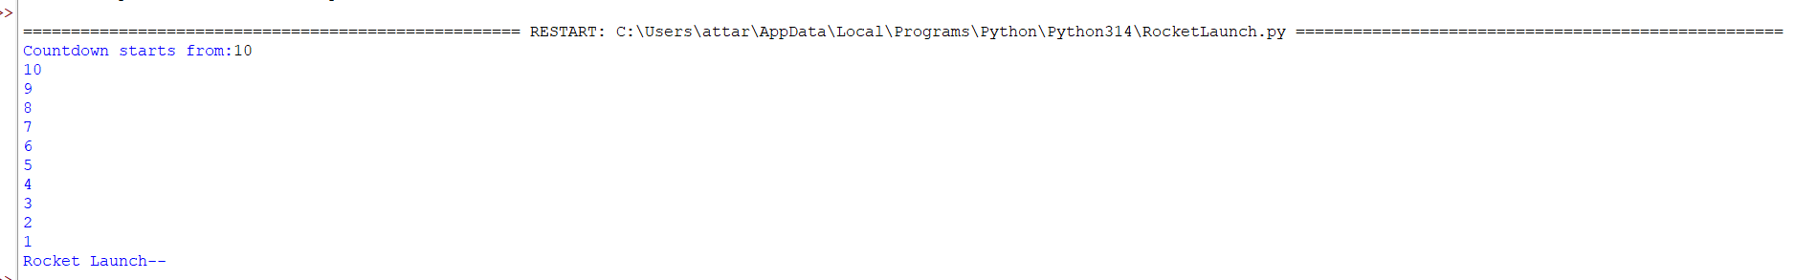

Explanation:
· The function launch(n) prints the current value of n.
· If n is greater than 0, it decreases n by 1 and calls itself recursively.
· The recursion continues until n becomes 0, which is the base case, and the function stops.

Error Table:
S.No | Error Obtained | Rectification
01. | Didn’t write the print statement after definition. | After execution I found the mistake and added it.

2)Aim: An HR department stores employee IDs in a list. Develop a program to search for a given employee ID. Write a recursive function to search for a employee ID in a list.
Program:
def Search(list,Search_element):
n=len(list)
i=0
while i<=n:
if(list[i]==Search_element):
return i
else:
i+=1
return -1
E_ID=[15,10,25,20,40]
key=int(input("Enter the Employee ID you want to search:"))
index =Search(E_ID,key)
print(index)
if index!=-1:
print(f"The Employee_ID is at index{index}")
else:
print("The given Employee_ID is invalid")
Output:
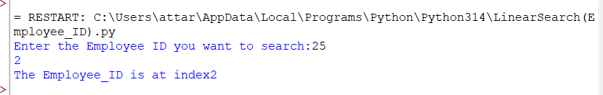
Explanation:
This program uses an iterative linear search to find an Employee ID in a list.
- The function Search(list, Search_element) is defined with two parameters:
  - list: The list in which the search is performed.
  - Search_element: The Employee ID to be searched.
- Inside the function, n = len(list) stores the total number of elements in the list, and i = 0 initializes the index for traversal.
- The while loop checks each element of the list one by one. If the current element matches the search element (list[i] == Search_element), the function returns the index i.
- If the current element does not match, the index is incremented using i += 1, and the search continues until all elements have been checked.
- If the Employee ID is not found after traversing the list, the function returns -1.
- The list E_ID = [15, 10, 25, 20, 40] is created, and the user is prompted to enter the Employee ID to search.
- The returned index is stored in the variable index.
- If index is not equal to -1, the program displays the index where the Employee ID is found. Otherwise, it prints "The given Employee_ID is invalid."
Error Table:

S.NO | Error Obtained | Rectification
1 | Index Error: list index out of range | Change the loop condition from while i <= n: to while i < n: so that the index does not exceed the valid range of the list.

3)Aim:
Program:
def CompoundInterest(P,N):
if N==0:
return 1
else:
return P**N
PrincipalRate=int(input("Enter the amount: "))
Year=int(input("Enter the number of years:"))
result=CompoundInterest(PrincipalRate,Year)
print(f"Compound Interest is:{result} Rupees only")
Output:
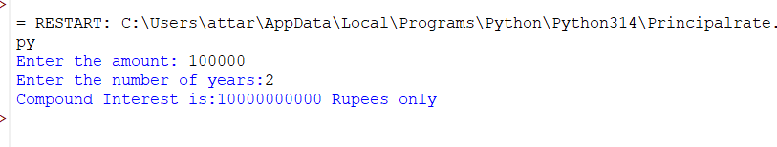
Explanation:
. The program is used to calculate the value of an amount raised to the power of the number of years using a function.
. It takes two inputs from the user:
- P → Principal amount (entered as PrincipalRate)
- N → Number of years (entered as Year)
. The function CompoundInterest(P, N) is called to calculate the result.
. If the value of N is 0, the function returns 1, since any number raised to the power 0 is 1.
. If N is not 0, the function returns P ** N, which calculates the principal amount raised to the given number of years using the exponent (**) operator.
. The returned value is stored in the variable result.
. Finally, the program prints the calculated result in the format:
"Compound Interest is: result Rupees only."

Error Table:
S. No | Error Obtained | Rectification
01. | Not a int value of n we can also take float in place of int, I have taken float value to check. | By replacing int by float.

4)Aim: In a logistical company ,the number of possible ways to arrange n different parcels is calculated using the factorial formula(n!).Develop a recursive program to calculate the factorial of a given number.
Program:
def fact(n):
if n==0:
return 1
elif n==1:
return 1
else:
return n*fact(n-1)
n=int(input("Enter the number of parcels:"))
print(fact(n))

Output:
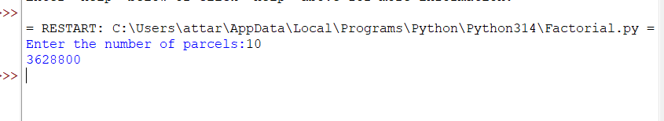
Explanation:
· The program defines a recursive function fact(n) to calculate the factorial of a number.
· The base condition checks if n ==0 or 1. If true, it returns 1 (for factorial, 0! = 1 and 1! = 1).
· Otherwise, the function returns n * fact(n-1), multiplying the current number by the factorial of the previous number.
· The function is called with the value 10.
· Finally, the program prints the factorial of 10, which is 3628800.
Error Table:
S. No | Error Obtained | Rectification
01. | No Errors obtained | ---------------------------------------------------

5)Aim: Write a recursive python program to print the first n terms of the Fibonacci series.
Program:
def fib(n):
if n==0:
return 0
elif n==1:
return 1
else:
return fib(n-1)+fib(n-2)
n=int(input("Enter the number of terms:"))
while n>=0:
fib(n)
print(fib(n))
n=n-1
Output:
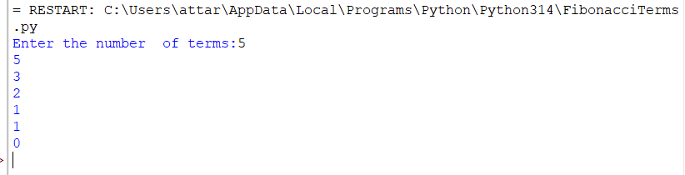

Explanation:
- The program uses a recursive function fib(n) to calculate Fibonacci numbers.
- The function returns 0 when n == 0 and 1 when n == 1. These are the base conditions of the recursion.
- For values greater than 1, the function returns the sum of the previous two Fibonacci numbers using fib(n-1) + fib(n-2).
- The user enters the number of terms (n).
- A while loop repeatedly calls the fib() function, prints the Fibonacci number corresponding to the current value of n, and then decreases n by 1.
- The loop continues until n becomes less than 0.
- Finally, the program displays the Fibonacci numbers in reverse order (from the entered value down to 0).
Error Table:

S. No | Error Obtained | Rectification
01. | No Errors obtained | Fibonacci numbers are printed in reverse order instead of the correct sequence.  Replace the while loop with a for loop such as for i in range(n): print(fib(i)) to display the Fibonacci series from 0 to n-1 in the correct order.

WEEK-2
Aim:
Write a python program to implement linear search on the given input.
Program:
def Linear_Search(nums,n,k):
n=len(nums)
i=0
while i<n:
if(nums[i]==k):
return i
else:
i+=1
return -1
n=int(input("Enter the number of elements in the array:"))
arr=[]
for i in range(n):
arr.append(int(input("Enter the element:")))
key=int(input("Enter the element to sarch in the array:"))
result=Linear_Search(arr,n,key)
if result!=-1:
print("Element found at index:"+str(result))
else:
print("Element does not exist in the array")

Output:
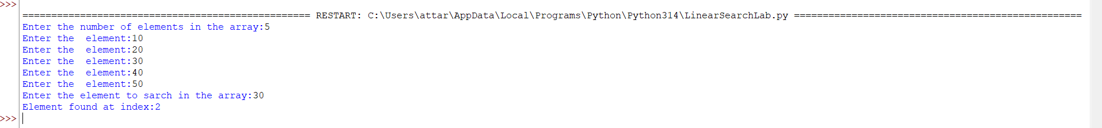

Explanation:
In this program, the function Linear_Search(nums, n, k) takes an array and a key as input. The variable i starts from 0, which represents the first index of the array. The while loop compares nums[i] with the key k.
- If nums[i] == k, the function returns the index i, meaning that the element has been successfully found.
- If the element does not match, i is increased by 1 and the next element is checked.
- If all elements are checked and the key is not found, the function returns -1.
The program then displays whether the element was found or does not exist in the array
.
  S. No. | Errors Obtained | Rectified
  1 | The value of n was passed to the function, but it was not actually required because the array length can be obtained directly. | Used n = len(nums) inside the function to get the actual number of elements.
  2 | If the search key was not found, there was no proper return value to indicate failure. | Added return -1 after the loop to indicate that the element does not exist.
  3 | The index variable i must be increased after an unsuccessful comparison. | Added i += 1 inside the else block.
  4 | The input message contained a spelling mistake: "sarch". | Corrected it to "search".
  5 | The output statement used string concatenation with an integer index. | Used str(result) to convert the index into a string before concatenation.
Error Table:

Aim: Write a python program to perform binary search on the given input. Verify by taking input as sorted array and unsorted array.
Program:
def Binary_Search(arr,key):
low=0
high=len(arr)-1
while low<=high:
mid=(low+high)//2
if(arr[mid]==key):
return mid
elif(arr[mid]<key):
low=mid+1
else:
high=mid-1
return -1
n=int(input("Enter the number of elements:"))
arr=[]
for i in range(n):
arr.append(int(input("Enter the element:")))
if arr == sorted(arr):
print("Array is already sorted")
else:
print("The array is not sorted")
print("The array is sorting")
arr.sort()
print("Sorted list:"+str(arr))
key=int(input("Enter the element to Search:"))
result=Binary_Search(arr,key)
if result!=-1:
print(f"Element {key} found at index {result}")
else:
print(f"Element {key} is not present in the list")

Output:
A)If the array is sorted:
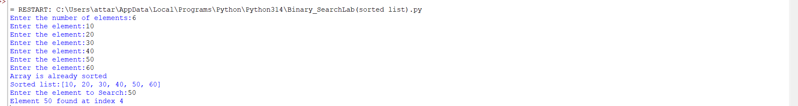

B)If the array is not sorted:
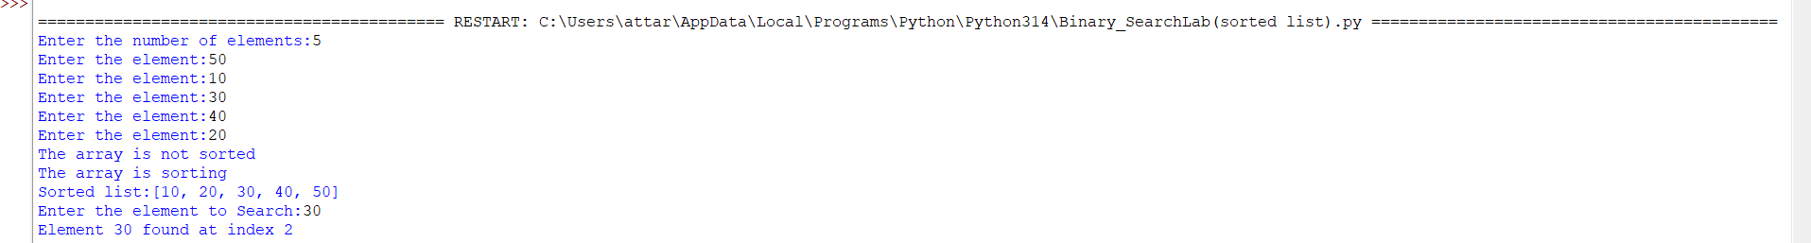
Explanation:
In this program, the user first enters the number of elements and the elements of the array. The program then checks whether the array is already sorted using:
if arr == sorted(arr):
If the array is already sorted, the program displays "Array is already sorted". Otherwise, it sorts the array using arr.sort().
The Binary_Search() function then performs the search. It uses three variables:
- low – represents the first index of the current search range.
- high – represents the last index of the current search range.
- mid – represents the middle index of the search range.
The middle element is calculated using:
mid = (low + high) // 2
The program compares the middle element with the search key:
- If arr[mid] == key, the element is found and its index is returned.
- If arr[mid] < key, the key must be in the right half, so low is changed to mid + 1.
- If arr[mid] > key, the key must be in the left half, so high is changed to mid - 1.

Error Table:

S.NO | Errors Obtained | Rectified
1 | Binary Search cannot be performed correctly on an unsorted array. | Checked whether the array is sorted and used arr.sort() when necessary.
2 | The middle index may be calculated incorrectly if normal division is used. | Used mid = (low + high) // 2 to obtain an integer index.
3 | The search range was not reduced correctly when the middle element was smaller than the key. | Updated low = mid + 1 to search the right half
4 | The search range was not reduced correctly when the middle element was greater than the key. | Updated high h = mid - 1 to search the left half.
5 | There was no proper indication when the search element was not found. | Added return -1 and displayed "Element is not present in the list" when the result is -1.

Week-3
Aim:
A) Write a python program to implement bubble sort.
Code:
def BubbleSort(arr):
n=len(arr)
for i in range(n-1):
for j in range(n-i-1):
if(arr[j]>arr[j+1]):
arr[j],arr[j+1]=arr[j+1],arr[j]
return arr
arr=[5,7,2,9,4]
result=BubbleSort(arr)
print(result)
Output:
Explanation:
The above Python program uses the Bubble Sort algorithm to arrange the elements of an array in ascending order.
1. Function Definition
def BubbleSort(arr):
This defines a function named BubbleSort that accepts an array (list) called arr.
2. Finding the Length
n = len(arr)
The len() function finds the number of elements in the list and stores it in the variable n.
3. Outer Loop
for i in range(n-1):
The outer loop controls the number of passes through the list. Bubble Sort requires a maximum of n-1 passes to sort n elements.
4. Inner Loop
for j in range(n-i-1):
The inner loop compares adjacent elements. After every pass, the largest unsorted element moves to its correct position at the end of the list.
5. Comparing Elements
if arr[j] > arr[j+1]:
The current element is compared with the next element. If the current element is greater than the next element, they need to be exchanged.
6. Swapping Elements
arr[j], arr[j+1] = arr[j+1], arr[j]
This statement swaps the two elements. Python allows two values to be exchanged in a single statement without requiring a temporary variable.
7. Returning the Sorted List
return arr
After sorting is completed, the function returns the sorted list.
8. Input
The given list is:
arr = [5, 7, 2, 9, 4]
9. Function Call
result = BubbleSort(arr)
The BubbleSort() function is called with the given list, and the sorted result is stored in result.
10. Displaying the Result
print(result)
This displays the sorted list on the screen.
Output
[2, 4, 5, 7, 9]
Error Table:
S .No. | Error Occurred | Rectification
1 | No error occurred | No rectification was required. The program executed successfully and produced the output [2,4,5,7,9]

B) Write a python program to implement Insertion sort.
Code:
def Insertion_Sort(arr):
n=len(arr)
for i in range(1,n):
key=arr[i]
j=i-1
while j>=0 and arr[j]>key:
arr[j+1]=arr[j]
j=j-1
arr[j+1]=key
return arr

arr=[50,20,40,30,10]
result=Insertion_Sort(arr)
print(result)
Output:
Explanation:
The given Python program uses the Insertion Sort algorithm to arrange the elements of a list in ascending order.
Logic of the Program
The main idea of Insertion Sort is to take one element at a time and insert it into its correct position in the already sorted part of the list.
- The program takes an array of numbers as input.
- The variable n stores the total number of elements.
- The loop starts from the second element because the first element is considered already sorted.
- The current element is stored in the variable key.
- The variable j points to the element just before the key.
- The program compares key with the elements before it.
- If an element is greater than key, it is moved one position to the right.
- This continues until the correct position for key is found.
- The key is then inserted into that position.
- The process is repeated for all elements.
- Finally, the sorted array is returned and printed.
Working Example
Given array:
[50, 20, 40, 30, 10]
Firstpass:
Take 20 and compare it with 50. Since 20 is smaller, 50 is shifted right.
[20, 50, 40, 30, 10]
Secondpass:
Take 40. It is smaller than 50, so 50 is shifted. 40 is placed after 20.
[20, 40, 50, 30, 10]
Thirdpass:
Take 30. It is smaller than 50 and 40, so those elements are shifted.
[20, 30, 40, 50, 10]
Fourthpass:
Take 10. All the previous elements are greater than 10, so they are shifted right.
[10, 20, 30, 40, 50]
Output
[10, 20, 30, 40, 50]
Important Logic
Select an element → Compare with previous elements → Shift larger elements → Insert the element in the correct position
Time Complexity
- Best Case: O(n)
- Average Case: O(n²)
- Worst Case: O(n²)
Conclusion
The program successfully sorts the given array in ascending order using the Insertion Sort algorithm. It works by gradually building a sorted portion of the array and inserting each new element into its appropriate position.

Error Table:
S .No. | Error Occurred | Rectification
1 | Identation erroroccurred because the statement arr[j+1] = key was incorrectly indented outside the for loop. | Corrected the indentation of  arr[j+1] = key so that it is properly aligned within the for loop.

C) write a python program to implement Selection sort.
Code:
def SelectionSort(arr):
n=len(arr)
for i in range(n-1):
min_index=i
for j in range(i+1,n):
if arr[j]<arr[min_index]:
min_index=j
arr[i],arr[min_index]=arr[min_index],arr[i]
return arr
arr=[64,25,12,22,11]
result=SelectionSort(arr)
print(result)
Output:
Logic of the Program
The main idea of Selection Sort is to find the smallest element from the unsorted part of the list and place it in the correct position.
- The program takes an array of numbers as input.
- The variable n stores the total number of elements in the array.
- The outer loop selects each position one by one.
- min_index is initially set to the current position i.
- The inner loop checks all the elements after the current position.
- If a smaller element is found, its index is stored in min_index.
- After checking all the remaining elements, the smallest element is swapped with the element at position i.
- The process is repeated until all elements are arranged in ascending order.
- Finally, the sorted array is returned and printed.
Working Example
Given array:
[64, 25, 12, 22, 11]
Firstpass:
Smallest element is 11. Swap it with 64.
[11, 25, 12, 22, 64]
Secondpass:
Smallest element in the remaining part is 12.
[11, 12, 25, 22, 64]
Thirdpass:
Smallest element is 22.
[11, 12, 22, 25, 64]
Fourthpass:
Smallest element is 25, so the array remains:
[11, 12, 22, 25, 64]
Output
[11, 12, 22, 25, 64]
Important Logic
Find minimum → Swap → Move to next position → Repeat
Selection Sort uses the selection and swapping method to arrange the elements in ascending order.
Time Complexity
- Best Case: O(n²)
- Average Case: O(n²)
- Worst Case: O(n²)
Conclusion
The program successfully sorts the given array in ascending order using the Selection Sort algorithm.

Explanation:
The given Python program uses the Selection Sort algorithm to arrange the elements in ascending order.

Error Table:
S .No. | Error Occurred | Rectification
1 | NameError occurred because SelectionSort was incorrectly written as Selection_Sort while calling the function. | Changed the function call to SelectionSort(arr) so that it matches the function definition.

D) write a python program to implement Merge sort.
Code:
def merge_sort(arr):
if len(arr)<=1:
return arr
mid=len(arr)//2
left=arr[:mid]
right=arr[mid:]
merge_sort(left)
merge_sort(right)
i=j=k=0
while i<len(left) and j<len(right):
if(left[i]<=right[j]):
arr[k]=left[i]
i+=1
else:
arr[k]=right[j]
j+=1
k+=1
while i<len(left):
arr[k]=left[i]
i+=1
k+=1
while j<len(right):
arr[k]=right[j]
j+=1
k+=1
return arr
arr=[10,30,50,70,90,60]
print(merge_sort(arr))
Output:

Explanation:
Logic of the Program
The main logic of Merge Sort is to divide the list into smaller parts, sort those parts, and then merge them together.
- The program receives an array of numbers.
- It checks whether the array contains one or zero elements. If yes, it returns the array because it is already sorted.
- The array is divided into two parts using the middle position.
- The merge_sort() function is called again for both the left and right parts. This continues until the parts contain only one element.
- The elements in the left and right parts are compared one by one.
- The smaller element is placed into the original array.
- If any elements are left over in either part, they are copied into the original array.
- The two sorted parts are therefore combined into one sorted array.
- Finally, the sorted array is returned and displayed.
Example of the Logic
For the input:
[10, 30, 50, 70, 90, 60]
The array is first divided:
[10, 30, 50] and [70, 90, 60]
These parts are divided further until individual elements are obtained. The elements are then compared and merged in sorted order.
The final result is:
[10, 30, 50, 60, 70, 90]
Important Logic Used
- Divide: Split the array into two halves.
- Recursion: Continue splitting until single elements remain.
- Compare: Compare elements from the two halves.
- Merge: Combine the elements in ascending order.
- Return: Return the completely sorted array.
Thus, the program uses the Divide and Conquer approach to sort the given elements efficiently.
Error Table:
S.NO. | Error Occurred | Rectification
1 | TypeError: object of type 'NoneType' has no len() may occur because the recursive calls merge_sort(left) and merge_sort(right) depend on their | Change them to left = merge_sort(left) and right = merge_sort(right).

E) write a python program to implement Quick sort.
Code:
def quickSort(a, low, high):
if low < high:
i = low
j = high
pivot = low
while i < j:
while i <len(a) and a[i] <= a[pivot]:
i += 1
while a[j] > a[pivot]:
j -= 1
if i < j:
a[i], a[j] = a[j], a[i]
# Place pivot in correct position
a[j], a[pivot] = a[pivot], a[j]

# Recursive calls
quickSort(a, low, j - 1)
quickSort(a, j + 1, high)

# Input
a = list(map(int, input("Enter numbers to sort: ").split()))
n = len(a)

quickSort(a, 0, n - 1)
print("Sorted array:", a)
Output:
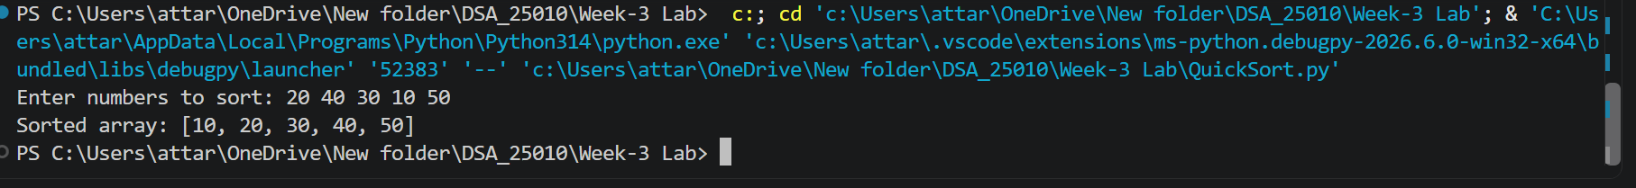
Explanation:
The program implements the Quick Sort algorithm.
It takes a list of numbers as input from the user.
The first element is selected as the pivot.
Two variables, i and j, are used to scan the array.
Elements are compared with the pivot and swapped when necessary.
The pivot is placed in its correct position after partitioning.
The program uses recursion to sort the left and right portions.
The process continues until the entire array is sorted.
Finally, the sorted array is displayed.
Example output: [10, 20, 30, 40, 50]

Error Table:
S.No | Error Occurred | Rectification
1 | IndexError: list index out of range may occur if the condition in the first inner loop is changed incorrectly and allows i to go beyond the valid array range. | Added the condition i < len(a) to ensure that i remains within the valid range of the array.

Week-4
Aim:
A)Write a python programme to implement a single linked list which could perform the below operations ,by taking an input from the user.
1)create a linked list
2)Insert at beginning
3)Insert at end
4)insert at index
5)Delete by value
6)Delete First Node
7)Delete Last Node
8)Count number of nodes
9)Display/Traverse
10)Exit
Code:
class Node:
def __init__(self, data):
self.data = data
self.next = None

class SLL:
def __init__(self):
self.head = None

# 1. Create Linked List
def create(self):
n = int(input("Enter number of nodes: "))

# Clear existing list before creating a new one
self.head = None

for i in range(n):
data = int(input("Enter data: "))
new_node = Node(data)

if self.head is None:
self.head = new_node
else:
temp = self.head

while temp.next is not None:
temp = temp.next

temp.next = new_node

print("Linked List created successfully.")

# 2. Insert at Beginning
def insert_beginning(self):
data = int(input("Enter data: "))

new_node = Node(data)
new_node.next = self.head
self.head = new_node

print(f"Inserted {data} at the beginning.")

# 3. Insert at End
def insert_end(self):
data = int(input("Enter data: "))

new_node = Node(data)

if self.head is None:
self.head = new_node
print(f"Inserted {data} at the end.")
return

temp = self.head

while temp.next is not None:
temp = temp.next

temp.next = new_node

print(f"Inserted {data} at the end.")

# 4. Insert at Index
def insert_at_index(self):
data = int(input("Enter data: "))
index = int(input("Enter index: "))

if index < 0:
print("Invalid index.")
return

if index == 0:
new_node = Node(data)
new_node.next = self.head
self.head = new_node

print(f"Inserted {data} at index {index}.")
return

temp = self.head

# Move to the node before the required index
for i in range(index - 1):
if temp is None:
print("Index out of range.")
return

temp = temp.next

if temp is None:
print("Index out of range.")
return

new_node = Node(data)

new_node.next = temp.next
temp.next = new_node

print(f"Inserted {data} at index {index}.")

# 5. Delete from Beginning
def delete_beginning(self):
if self.head is None:
print("List is empty.")
return

deleted_data = self.head.data
self.head = self.head.next

print(f"Deleted {deleted_data} from the beginning.")

# 6. Delete from End
def delete_end(self):
if self.head is None:
print("List is empty.")
return

# Only one node
if self.head.next is None:
deleted_data = self.head.data
self.head = None

print(f"Deleted {deleted_data} from the end.")
return

temp = self.head

# Move to second-last node
while temp.next.next is not None:
temp = temp.next

deleted_data = temp.next.data
temp.next = None

print(f"Deleted {deleted_data} from the end.")

# 7. Delete from Index
def delete_at_index(self):
index = int(input("Enter index: "))

if self.head is None:
print("List is empty.")
return

if index < 0:
print("Invalid index.")
return

# Delete first node
if index == 0:
deleted_data = self.head.data
self.head = self.head.next

print(f"Deleted {deleted_data} from index {index}.")
return

temp = self.head

# Move to node before the required index
for i in range(index - 1):
if temp.next is None:
print("Index out of range.")
return

temp = temp.next

if temp.next is None:
print("Index out of range.")
return

deleted_data = temp.next.data
temp.next = temp.next.next

print(f"Deleted {deleted_data} from index {index}.")

# 8. Count Nodes
def count_nodes(self):
count = 0
temp = self.head

while temp is not None:
count += 1
temp = temp.next

print("Number of nodes:", count)

# 9. Display
def display(self):
if self.head is None:
print("List is empty.")
return

temp = self.head

while temp is not None:
print(temp.data, end=" -> ")
temp = temp.next

print("None")

# Main Program
sll = SLL()

while True:
print("\n----- SINGLY LINKED LIST -----")
print("1. Create Linked List")
print("2. Insert at Beginning")
print("3. Insert at End")
print("4. Insert at Index")
print("5. Delete from Beginning")
print("6. Delete from End")
print("7. Delete from Index")
print("8. Count Number of Nodes")
print("9. Display")
print("10. Exit")

choice = int(input("Enter your choice: "))

if choice == 1:
sll.create()

elif choice == 2:
sll.insert_beginning()

elif choice == 3:
sll.insert_end()

elif choice == 4:
sll.insert_at_index()

elif choice == 5:
sll.delete_beginning()

sll.delete_end()

elif choice == 7:
sll.delete_at_index()

elif choice == 8:
sll.count_nodes()

elif choice == 9:
sll.display()

elif choice == 10:
print("Exiting from the program...")
break

else:
print("Invalid choice.")
Output:
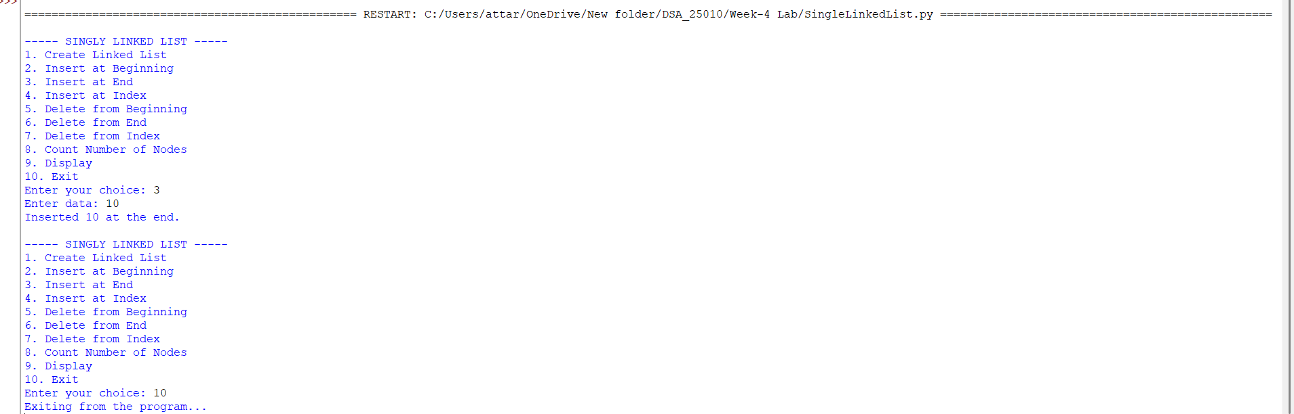
Explanation:
This program implements a Singly Linked List in Python using a menu-driven approach. It first takes array elements as input and converts them into linked-list nodes. The program provides operations to insert nodes at the beginning, end, or a specific index, and to delete nodes from the beginning, end, or by a specific value. It can also count the number of nodes and display the linked list.
- The program implements a Singly Linked List using Node and SinglyLinkedList classes.
- Each node contains data and a next pointer that stores the reference to the next node.
- The head points to the first node of the linked list.
- The program supports insertion at the beginning, end, and a specific position.
- It supports deletion by value, from the beginning, and from the end.
- The count_nodes() function counts the total number of nodes.
- The display() function traverses and prints all nodes in the list.
- A menu-driven program is used to allow the user to select different operations.

Error Table:

S .No. | Error Occurred | Rectification
1 | Constructor was written as _init_ instead of __init__. | Changed _init_ to __init__ in both Node and SLL classes.
2 | Node object was not initialized correctly. | Added self.data = data and self.next = None in the Node constructor.
3 | SLL object did not have a head attribute. | Added self.head = None in the SLL constructor.
4 | Insertion at an invalid index could cause an error. | Added index validation and an "Index out of range" message.
5 | Negative index was accepted. | Added a condition to display "Invalid index" for negative indexes.
6 | Deletion from an empty list could not be performed. | Added an empty-list check before deletion.
7 | Deletion from the end required special handling for a single-node list. | Added a condition to check whether the list contains only one node.
8 | The deleted node value was not displayed clearly. | Stored the deleted value in deleted_data and displayed it in the output.
9 | Creating a new linked list could retain previous nodes. | Added self.head = None at the beginning of the create() function.

B) Write a python program to implement a Double linked list which could perform the below operations ,by taking an input from the user.
1)Insert at beginning
2)Insert at end
3)insert at index
4)Delete by value
5)Delete First Node
6)Delete Last Node
7)Display the Forward Nodes
8)Display the Backward Nodes
9)Exit

Code:
class Node:
def __init__(self, data):
self.prev = None
self.data = data
self.next = None

class DoublyLinkedList:
def __init__(self):
self.head = None

def insert_begin(self, data):
new = Node(data)
if self.head is None:
self.head = new
else:
new.next = self.head
self.head.prev = new
self.head = new
print("Insertion Completed")

def insert_end(self, data):
new = Node(data)
if self.head is None:
self.head = new
else:
temp = self.head
while temp.next:
temp = temp.next
temp.next = new
new.prev = temp
print("Insertion Completed")

def insert_index(self, index, data):
if index < 0:
print("Invalid Index")
elif index == 0:
self.insert_begin(data)
else:
new = Node(data)
temp = self.head
for i in range(index - 1):
if temp is None:
print("Invalid Index")
return
temp = temp.next
new.next = temp.next
new.prev = temp
if temp.next:
temp.next.prev = new
temp.next = new
print("Insertion Completed")

def deleteBeg(self):
if self.head is None:
print("Can't perform delete operation")
elif self.head.next is None:
self.head = None
print("Value Deleted")
else:
self.head.next.prev = None
self.head = self.head.next
print("Value Deleted")

def deleteEnd(self):
if self.head is None:
print("Can't perform delete operation")
elif self.head.next is None:
self.head = None
print("Value Deleted")
else:
temp = self.head
while temp.next:
temp = temp.next
temp.prev.next = None
print("Value Deleted")

def deleteIndex(self, index):
if self.head is None:
print("Can't perform delete operation")
elif index < 0:
print("Invalid Index")
elif index == 0:
self.deleteBeg()
else:
temp = self.head
for i in range(index):
if temp is None:
print("Invalid Index")
return
temp = temp.next
if temp is None:
print("Invalid Index")
elif temp.next:
temp.next.prev = temp.prev
temp.prev.next = temp.next
print("Value Deleted")
else:
temp.prev.next = None
print("Value Deleted")

def displayFwd(self):
temp = self.head
while temp:
print(temp.data, end=" <-> ")
temp = temp.next
print("None")

def displayBwd(self):
if self.head is None:
print("None")
return
temp = self.head
while temp.next:
temp = temp.next
while temp:
print(temp.data, end=" <-> ")
temp = temp.prev
print("None")

# Main menu
Dll = DoublyLinkedList()

while True:
print("\n1.Insert Beginning")
print("2.Insert End")
print("3.Insert at Index")
print("4.Delete at Beginning")
print("5.Delete at End")
print("6.Delete at Specific Index")
print("7.Display Forward")
print("8.Display Backward")
print("9.Exit")

ch = int(input("Choice: "))

if ch == 1:
x = int(input("Value: "))
Dll.insert_begin(x)
Dll.displayFwd()
elif ch == 2:
x = int(input("Value: "))
Dll.insert_end(x)
Dll.displayFwd()
elif ch == 3:
idx = int(input("Index: "))
x = int(input("Value: "))
Dll.insert_index(idx, x)
Dll.displayFwd()
elif ch == 4:
Dll.deleteBeg()
Dll.displayFwd()
elif ch == 5:
Dll.deleteEnd()
Dll.displayFwd()
elif ch == 6:
idx = int(input("Index: "))
Dll.deleteIndex(idx)
Dll.displayFwd()
elif ch == 7:
Dll.displayFwd()
elif ch == 8:
Dll.displayBwd()
elif ch == 9:
print("Loop Terminated")
break

Output:
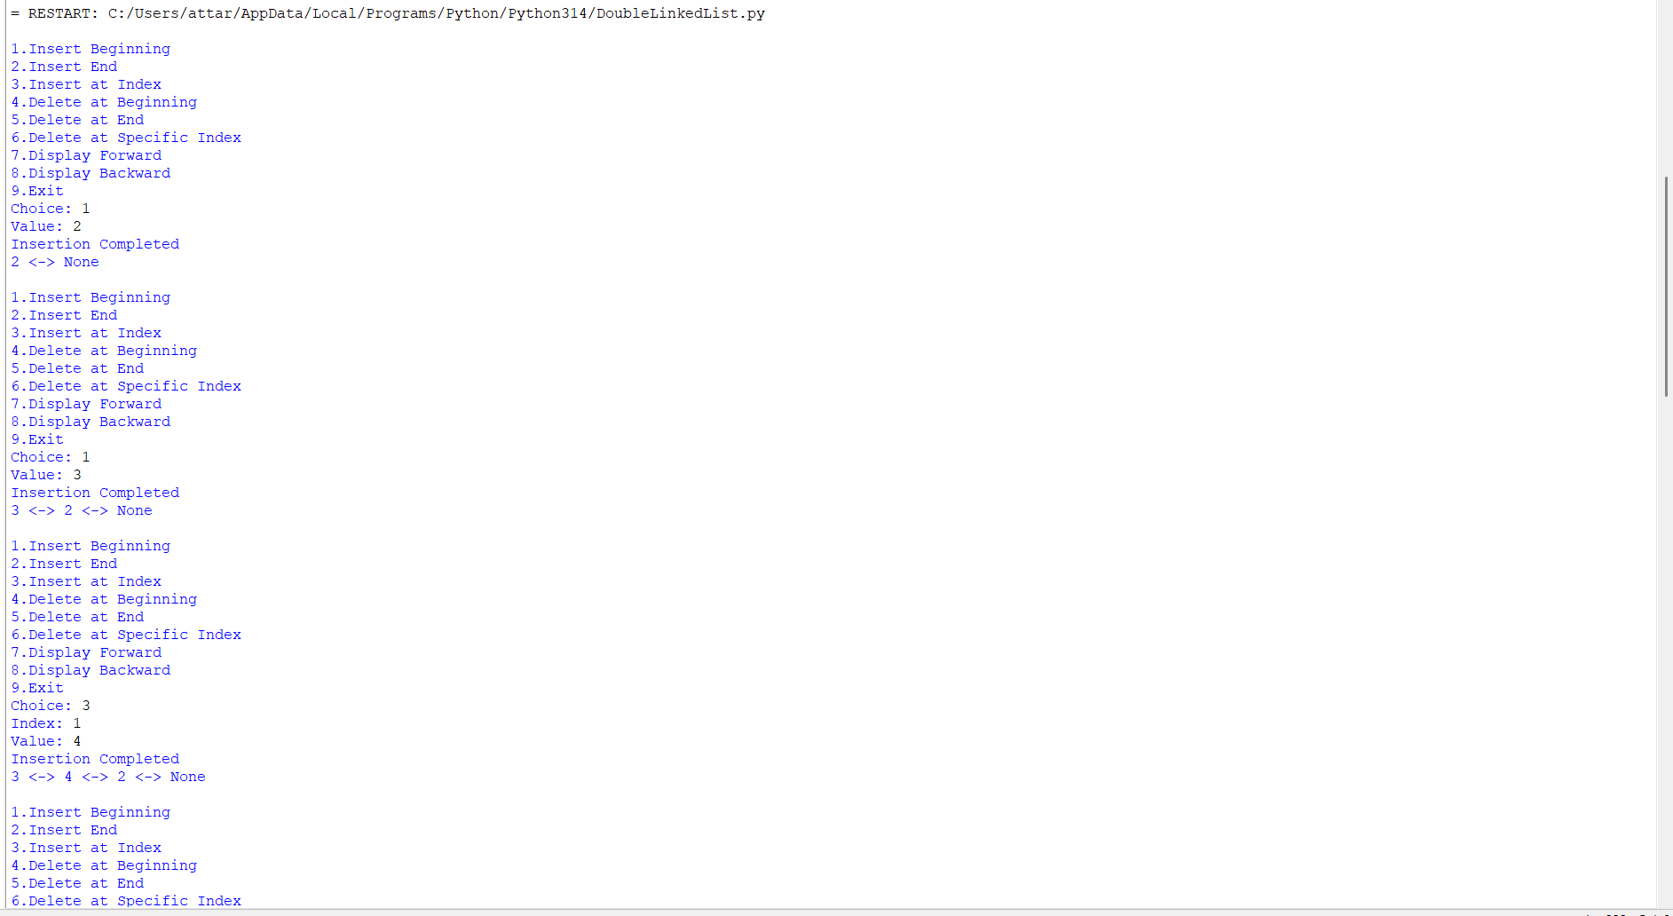
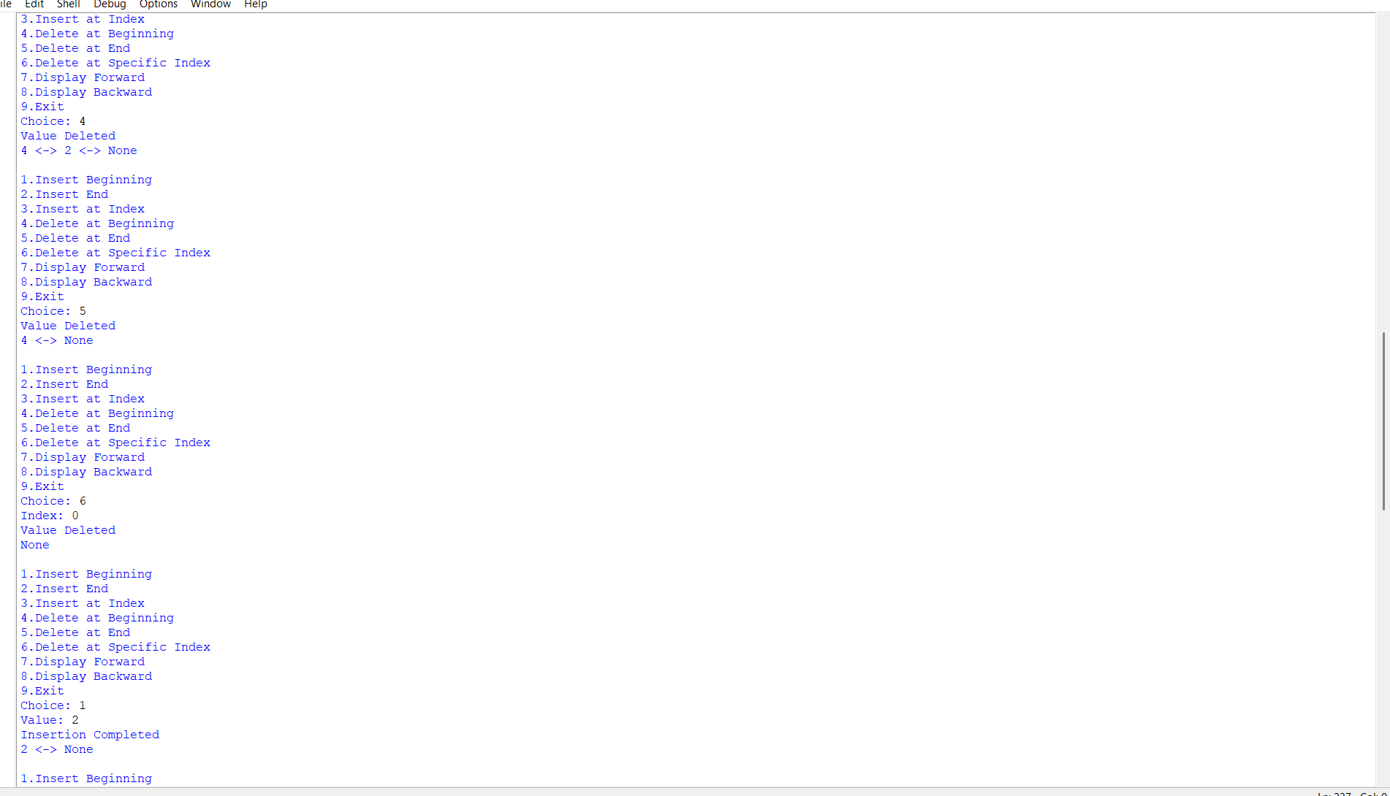
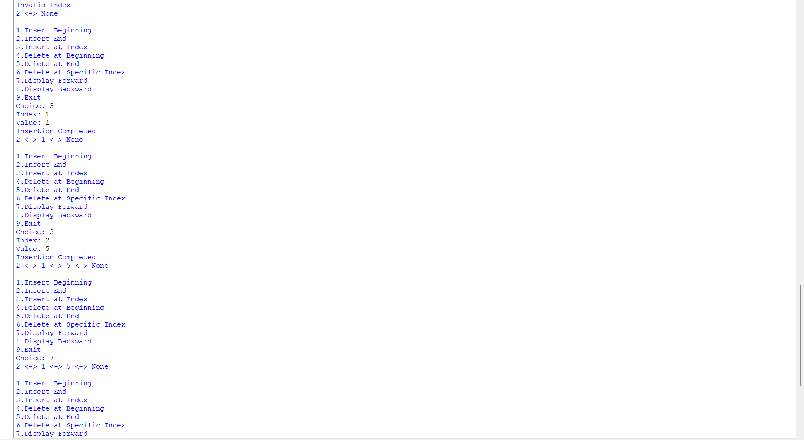
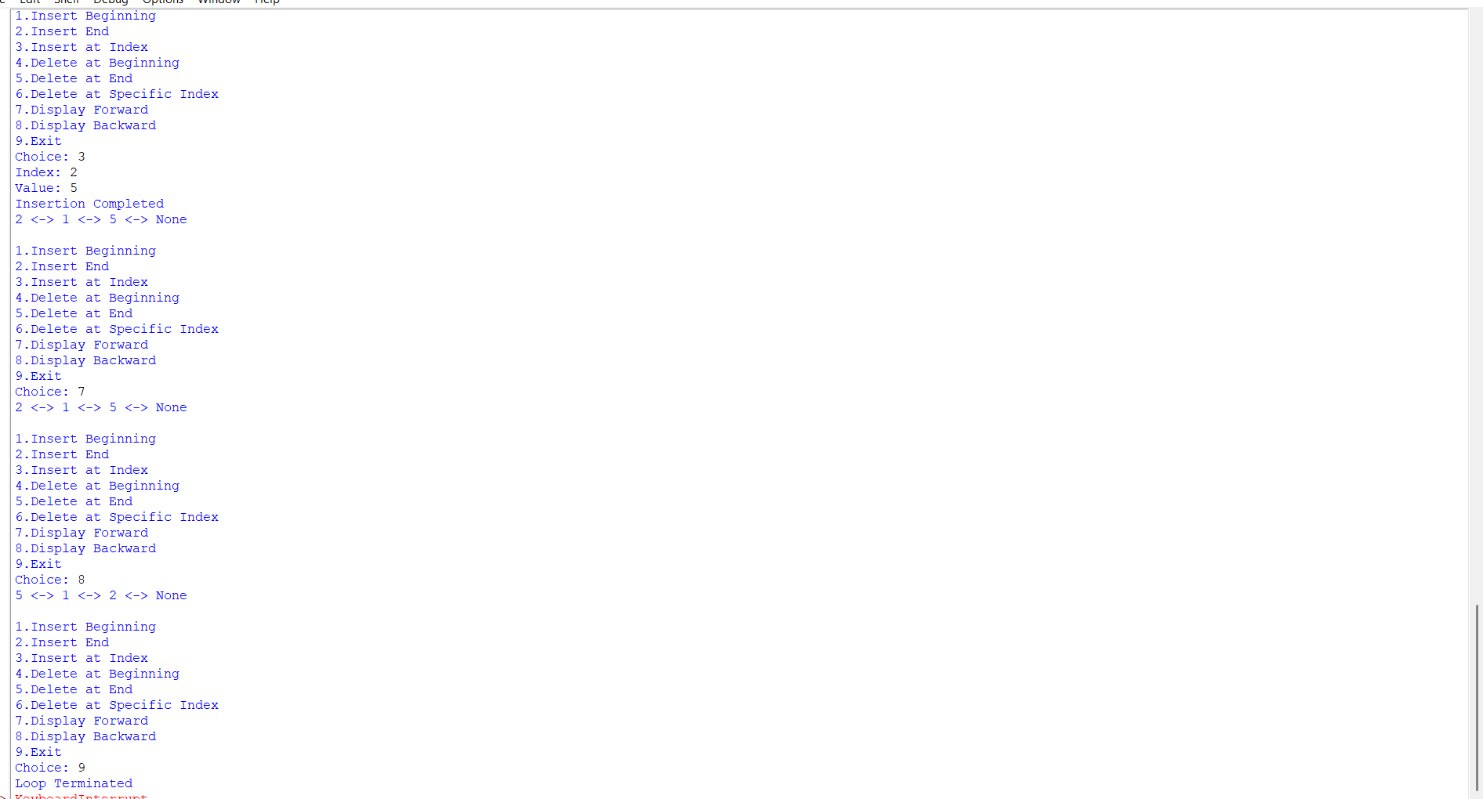
Explanation:
1. Introduction
A Doubly Linked List (DLL) is a data structure where each node contains:
- Data
- A pointer to the next node
- A pointer to the previous node
This allows traversal in both directions (forward and backward).
2. Code Explanation
🔹 Node Class
python
class Node:
def __init__(self, data):
self.prev = None
self.data = data
self.next = None
- Each node stores data, a link to the previous node (prev), and a link to the next node (next).
🔹 DoublyLinkedList Class
python
class DoublyLinkedList:
def __init__(self):
self.head = None
- Initializes the list with head = None (empty list).
🔹 Insertion Methods
- Insert at Beginning
  - Creates a new node.
  - If list is empty → new node becomes head.
  - Otherwise → new node points to old head, and old head points back to new node.
- Insert at End
  - Traverses to the last node.
  - Adds new node at the end and updates prev.
- Insert at Specific Index
  - Traverses to the given index.
  - Inserts new node between nodes, adjusting both next and prev.
🔹 Deletion Methods
- Delete at Beginning
  - Removes the head node.
  - Updates new head’s prev to None.
- Delete at End
  - Traverses to the last node.
  - Removes it by updating the second-last node’s next to None.
- Delete at Specific Index
  - Traverses to the given index.
  - Removes the node by linking its previous and next nodes together.
🔹 Display Methods
- Forward Traversal
  - Starts at head and prints nodes until the end (None).
- Backward Traversal
  - Traverses to the last node.
  - Prints nodes in reverse using prev.
🔹 Menu-Driven Program
- Provides options for insertion, deletion, and display.
- Runs in a loop until user chooses Exit.
4. Conclusion
This program demonstrates:
- Insertion (beginning, end, index)
- Deletion (beginning, end, index)
- Traversal (forward and backward)
It is a menu-driven implementation of a Doubly Linked List in Python, useful for understanding linked list operations step by step.

Error Table:

S.No | Error Occurred | Rectification
1 | deleteBeg function was written outside the class (wrong indentation). | Move deleteBeg inside the DoublyLinkedList class with proper indentation.
2 | Missing print("Insertion Completed") in insert_begin when list is empty. | Add print("Insertion Completed") after setting head.
3 | In insert_index, if self.head is None, program may crash. | Add check: if self.head is None: print("Invalid Index"); return.
4 | In deleteIndex, loop may go beyond list length. | Add condition: if temp is None: print("Invalid Index"); return.
5 | Inconsistent naming (deleteBeg vs delete_begin). | Use consistent naming convention for methods.
6 | No safeguard for negative index in insert_index. | Add if index < 0: print("Invalid Index"); return.

C) Write a python program to implement a Circular linked list which could perform the below operations ,by taking an input from the user.
1)create a linked list
2)Insert at beginning
3)Insert at end
4)insert at index
5)Delete by value
6)Delete First Node
7)Delete Last Node
8)Count number of nodes
9)Display
a)Head to Tail
b)Tail to Head
10)Exit
Code:
class Node:
def __init__(self, data):
self.data = data
self.next = None

class CircularLinkedList:

def __init__(self):
self.head = None

# a. Create Linked List
def create(self):
n = int(input("Enter number of nodes: "))
for i in range(n): # loop for each node
data = int(input("Enter data: "))
new_node = Node(data)

if self.head is None: # first node
self.head = new_node
new_node.next = self.head
else: # subsequent nodes
temp = self.head
while temp.next != self.head:
temp = temp.next
temp.next = new_node
new_node.next = self.head

print("Circular Linked List created successfully.")
# b. Insert at Beginning
def insert_beginning(self):
data = int(input("Enter data: "))
new_node = Node(data)

if self.head is None:
self.head = new_node
new_node.next = self.head
else:
temp = self.head
while temp.next != self.head:
temp = temp.next
new_node.next = self.head
temp.next = new_node
self.head = new_node

print(f"Inserted {data} at the beginning.")

# c. Insert at End
def insert_end(self):
data = int(input("Enter data: "))
new_node = Node(data)

if self.head is None:
self.head = new_node
new_node.next = self.head
else:
temp = self.head
while temp.next != self.head:
temp = temp.next
temp.next = new_node
new_node.next = self.head

print(f"Inserted {data} at the end.")

# d. Insert at Specific Index
def insert_at_index(self):
index = int(input("Enter index: "))
data = int(input("Enter data: "))

if index < 0:
print("Invalid index.")
return

if index == 0:
self.insert_beginning()
return

if self.head is None:
print("Index out of range.")
return

new_node = Node(data)
temp = self.head

for i in range(index - 1):
temp = temp.next
if temp == self.head:
print("Index out of range.")
return

new_node.next = temp.next
temp.next = new_node

print(f"Inserted {data} at index {index}.")

# e. Delete by Value
def delete_by_value(self):
value = int(input("Enter value to delete: "))

if self.head is None:
print("Circular Linked List is empty.")
return

if self.head.data == value:
if self.head.next == self.head:
self.head = None
else:
temp = self.head
while temp.next != self.head:
temp = temp.next
temp.next = self.head.next
self.head = self.head.next
print(f"Deleted {value}.")
return

temp = self.head
while temp.next != self.head:
if temp.next.data == value:
temp.next = temp.next.next
print(f"Deleted {value}.")
return
temp = temp.next

print(f"{value} not found in the Linked List.")

# f. Delete First Node
def delete_first(self):
if self.head is None:
print("Circular Linked List is empty.")
return

deleted = self.head.data
if self.head.next == self.head:
self.head = None
else:
temp = self.head
while temp.next != self.head:
temp = temp.next
temp.next = self.head.next
self.head = self.head.next

print(f"Deleted first node: {deleted}")

# g. Delete Last Node
def delete_last(self):
if self.head is None:
print("Circular Linked List is empty.")
return

if self.head.next == self.head:
deleted = self.head.data
self.head = None
print(f"Deleted last node: {deleted}")
return

temp = self.head
while temp.next.next != self.head:
temp = temp.next

deleted = temp.next.data
temp.next = self.head

print(f"Deleted last node: {deleted}")

# h. Count Number of Nodes
def count_nodes(self):
if self.head is None:
print("Number of nodes: 0")
return

count = 0
temp = self.head
while True:
count += 1
temp = temp.next
if temp == self.head:
break

print("Number of nodes:", count)

# i. Display
def display(self):
if self.head is None:
print("Circular Linked List is empty.")
return

temp = self.head
print("Circular Linked List:", end=" ")
while True:
print(temp.data, end=" -> ")
temp = temp.next
if temp == self.head:
break
print("HEAD")

# 1. Display Head and Tail
def display_head_tail(self):
if self.head is None:
print("Circular Linked List is empty.")
return

temp = self.head
while temp.next != self.head:
temp = temp.next
tail = temp

print("Head:", self.head.data)
print("Tail:", tail.data)

# 2. Print Data from Tail to Head
def display_tail_to_head(self):
if self.head is None:
print("Circular Linked List is empty.")
return

tail = self.head
while tail.next != self.head:
tail = tail.next

print("Data from Tail to Head:", end=" ")
current = tail
while True:
print(current.data, end=" ")
if current == self.head:
break
temp = self.head
while temp.next != current:
temp = temp.next
current = temp
print()

# Menu-driven program
cll = CircularLinkedList()

while True:
print("\n----- CIRCULAR LINKED LIST -----")
print("1. Create Linked List")
print("2. Insert at Beginning")
print("3. Insert at End")
print("4. Insert at Specific Index")
print("5. Delete by Value")
print("6. Delete First Node")
print("7. Delete Last Node")
print("8. Count Number of Nodes")
print("9. Display")
print("10. Display Head and Tail")
print("11. Print Data from Tail to Head")
print("12. Exit")

choice = int(input("Enter your choice: "))

if choice == 1:
cll.create()
elif choice == 2:
cll.insert_beginning()
elif choice == 3:
cll.insert_end()
elif choice == 4:
cll.insert_at_index()
elif choice == 5:
cll.delete_by_value()
elif choice == 6:
cll.delete_first()
elif choice == 7:
cll.delete_last()
elif choice == 8:
cll.count_nodes()
elif choice == 9:
cll.display()
elif choice == 10:
cll.display_head_tail()
elif choice == 11:
cll.display_tail_to_head()
elif choice == 12:
print("Exiting program....")
break
else:
print("Invalid choice. Please try again.")
Output:
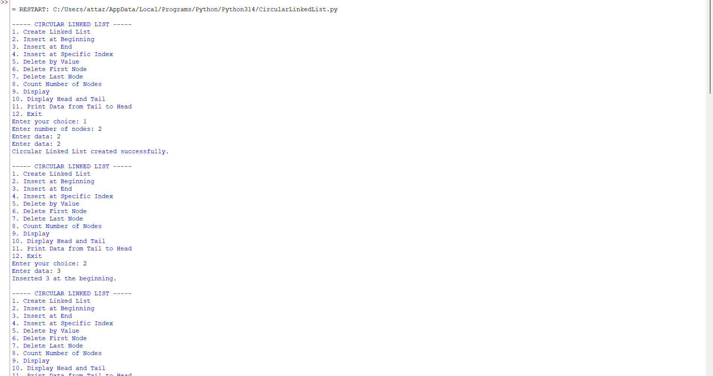
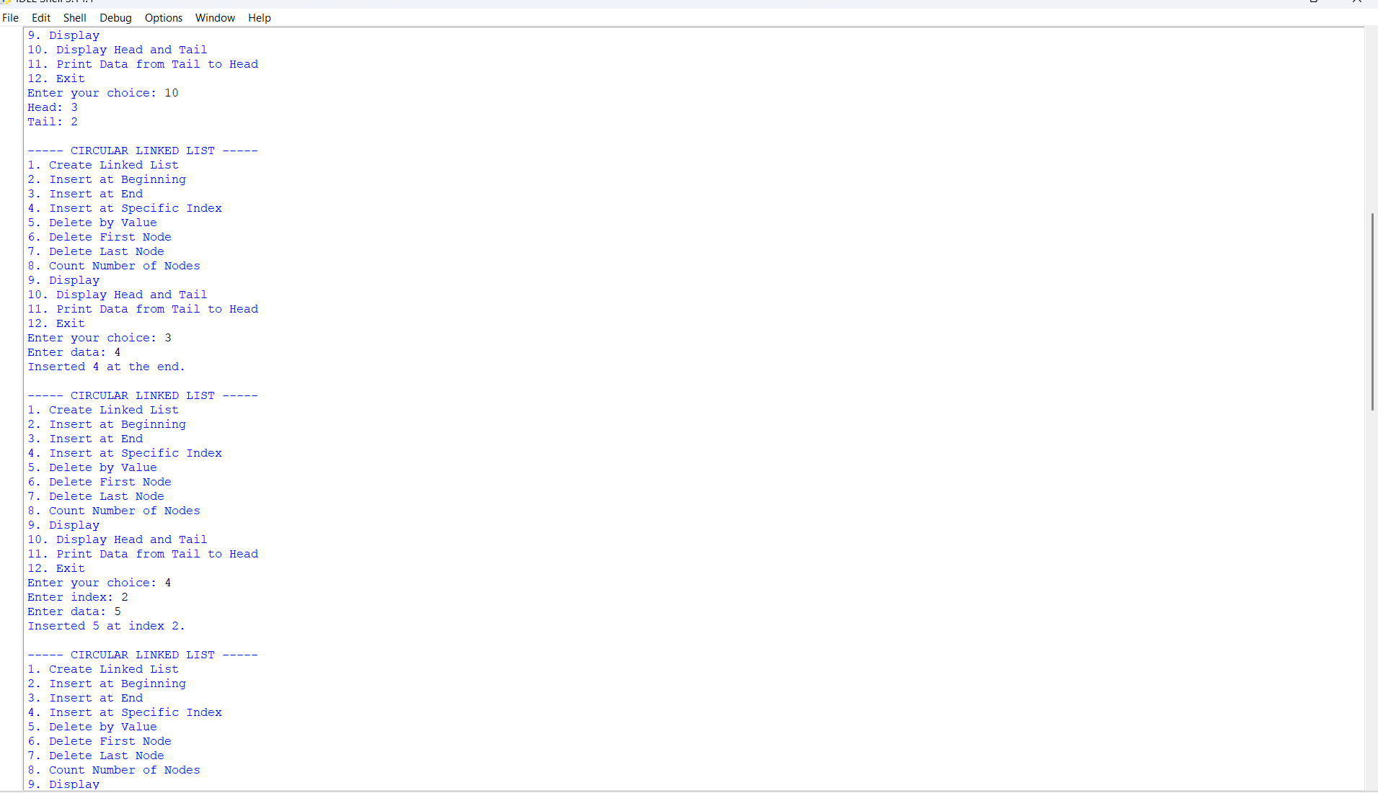
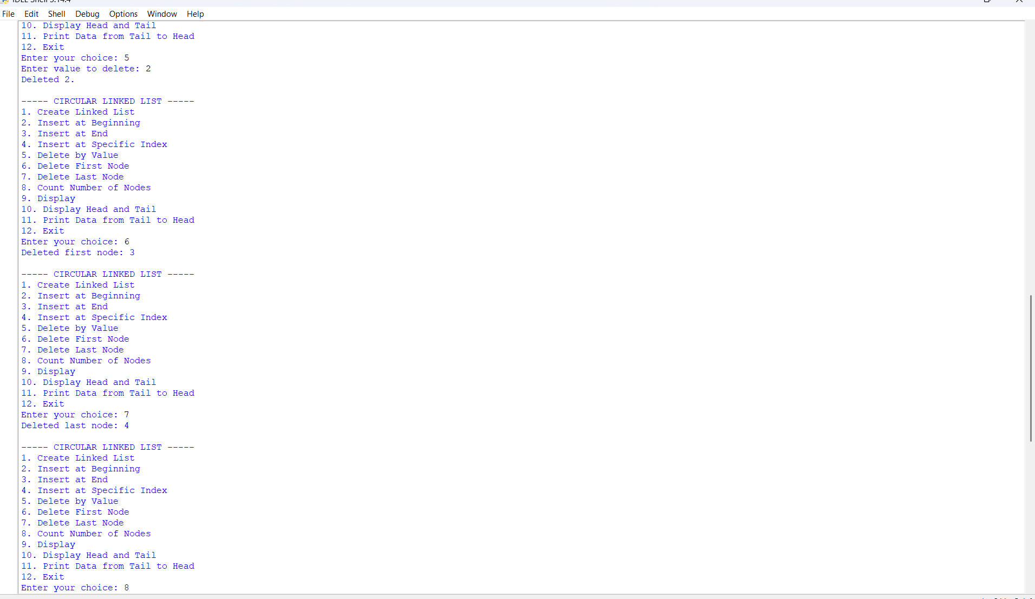
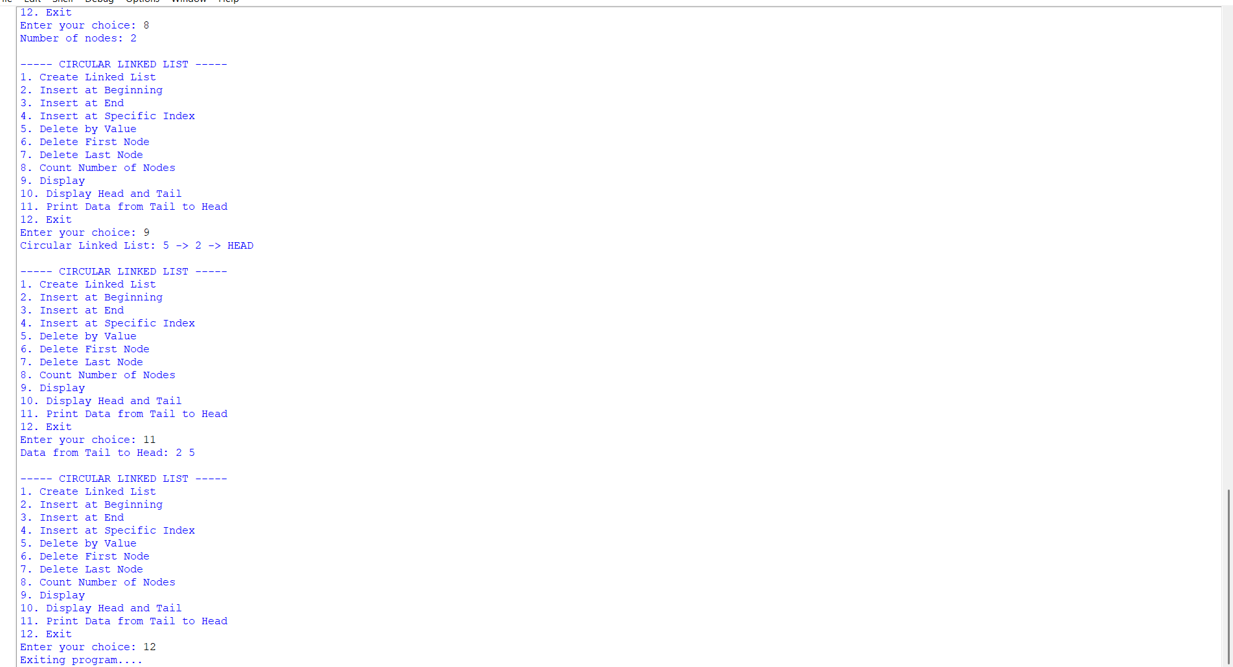
Explanation:
1. Introduction
A Circular Linked List (CLL) is a variation of a linked list where:
- The last node points back to the first node (head).
- This creates a circular structure, allowing traversal to continue indefinitely.
- Useful in applications like round-robin scheduling and buffer management.
2. Node Class
python
class Node:
def __init__(self, data):
self.data = data
self.next = None
- Each node contains:
  - data: stores the value.
  - next: points to the next node in the list.
3. CircularLinkedList Class
a) Initialization
python
class CircularLinkedList:
def __init__(self):
self.head = None
- Starts with an empty list (head = None).
b) Insertion Operations
- Insert at Beginning
  - Creates a new node.
  - If list is empty → new node points to itself.
  - Otherwise → new node becomes head, and last node points to new head.
- Insert at End
  - Traverses to the last node.
  - Adds new node at the end and links it back to head.
- Insert at Specific Index
  - Traverses to the given index.
  - Inserts new node between nodes.
  - Adjusts links to maintain circular structure.
c) Deletion Operations
- Delete by Value
  - Searches for a node with the given value.
  - Removes it by adjusting links.
  - If value not found → prints error message.
- Delete First Node
  - Removes the head node.
  - Updates head to next node.
  - Last node points to new head.
- Delete Last Node
  - Traverses to the second-last node.
  - Removes last node by linking it back to head.
d) Utility Operations
- Count Nodes
  - Traverses the list until it returns to head.
  - Counts total nodes.
- Display
  - Prints all nodes in forward direction.
  - Ends with HEAD to show circular connection.
- Display Head and Tail
  - Prints the first node (head) and last node (tail).
- Display Tail to Head
  - Traverses backward from tail to head.
  - Prints nodes in reverse order.
e) Menu-Driven Program
- Provides options for:
  - Insertion
  - Deletion
  - Display
  - Counting nodes
- Runs in a loop until user chooses Exit.
4. Conclusion
This program demonstrates:
- Insertion (beginning, end, index)
- Deletion (by value, first node, last node)
- Traversal (forward, backward, head-tail)
- Counting nodes
It is a menu-driven implementation of a Circular Linked List in Python, useful for understanding circular data structures step by step

Error Table:

S.No | Error Occurred | Rectification
1 | __init__ used instead of __init__ in constructors. | Replace with __init__ (double underscores).
2 | In insert_at_index, if list is empty, program may crash. | Add check: if self.head is None: print("Index out of range"); return.
3 | In delete_by_value, if value not found, loop may continue infinitely. | Ensure condition if temp.next == self.head: break.
4 | In delete_last, if only one node exists, temp.next.next causes error. | Add condition: if self.head.next == self.head: self.head = None.
5 | In display_tail_to_head, traversal logic is complex and may cause infinite loop. | Use a helper function to find previous node safely.
6 | No safeguard for negative index in insert_at_index. | Add if index < 0: print("Invalid Index"); return.

WEEK-5

Aim: WAP python to implement a stack using an array, linked list ,also implement the stack operations such as:
a)push
b)pop
c)peek also display the stack elements
Code:(Implementation using Arrays)
class StackEx:
def __init__(self, size):
self.size = size
self.stack = [None] * size
self.top = -1

# Push operation
def push(self, item):
if self.top == self.size - 1:
print("Stack Overflow")
else:
self.top += 1
self.stack[self.top] = item
print(item, "pushed into the stack")
# Pop operation
def pop(self):
if self.top == -1:
print("Stack Underflow")
else:
item = self.stack[self.top]
self.stack[self.top] = None
self.top -= 1
print(item, "popped from the stack")

# Peek operation
def peek(self):
if self.top == -1:
print("Stack is empty")
else:
print("Top element:", self.stack[self.top])

# Display operation
def display(self):
if self.top == -1:
print("Stack is empty")
else:
print("The elements of the stack are:")
for i in range(self.top, -1, -1):
print(self.stack[i])
# Create stack
size = int(input("Enter the size of the stack: "))
s = StackEx(size)
while True:
print("\n----- STACK MENU -----")
print("1. Push")
print("2. Pop")
print("3. Peek")
print("4. Display")
print("5. Exit")
choice = int(input("Enter your choice: "))
if choice == 1:
item = int(input("Enter the element to push: "))
s.push(item)
elif choice == 2:
s.pop()
elif choice == 3:
s.peek()
elif choice == 4:
s.display()
elif choice == 5:
print("Program terminated.")
break
else:
print("Invalid choice")
Output:
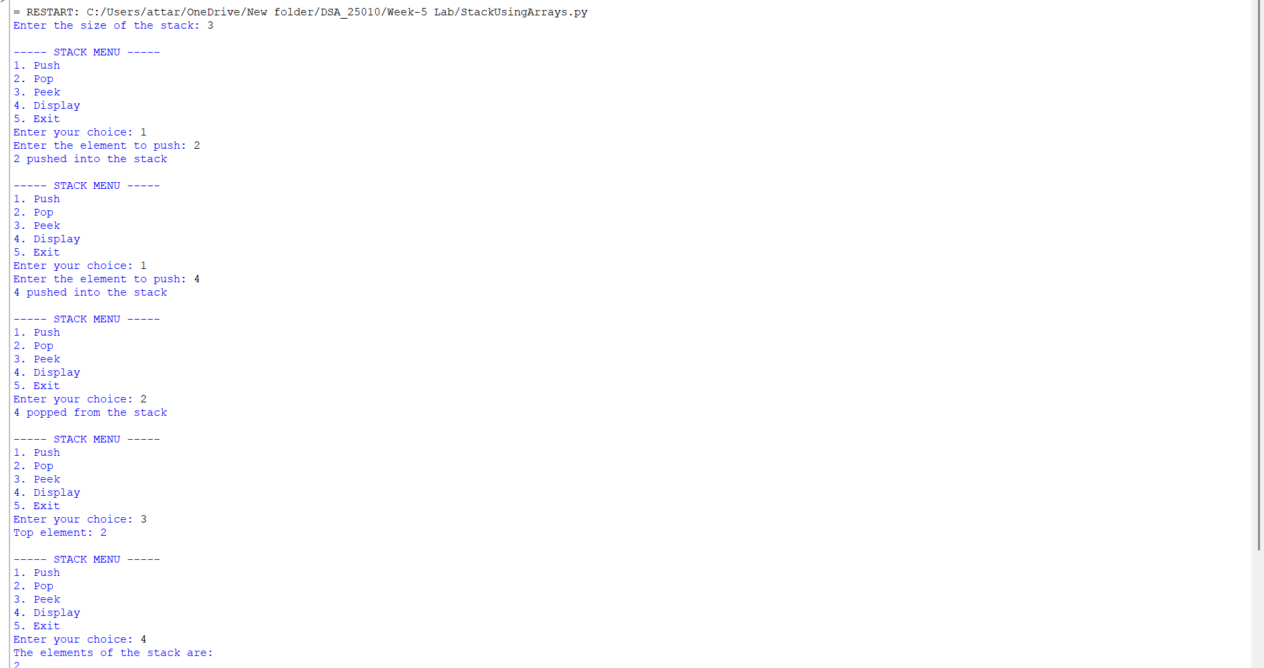
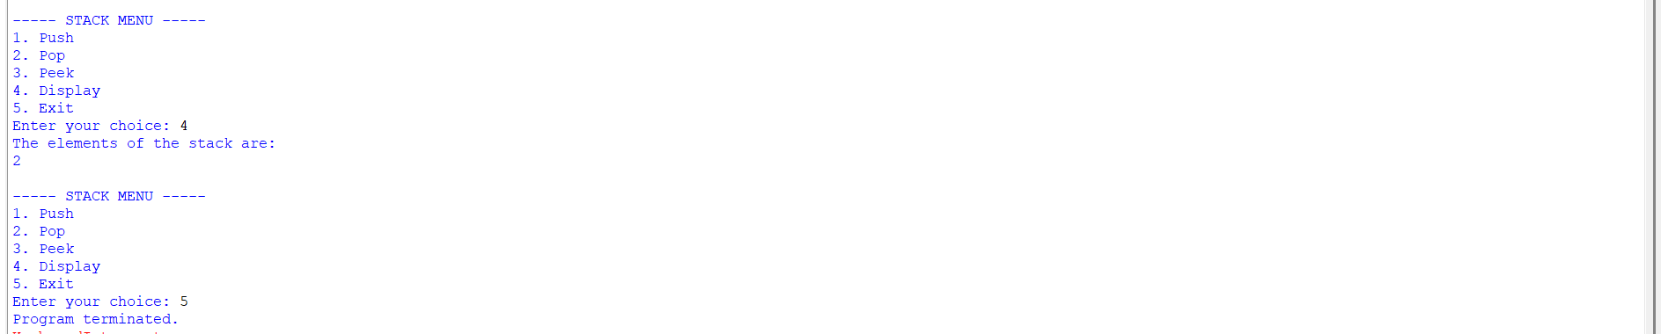

Code:(Implementation using Linked List)
class Node:
def __init__(self, data):
self.data = data
self.next = None

class Stack:
def __init__(self):
self.top = None

# Push operation
def push(self, data):
new = Node(data)
new.next = self.top
self.top = new
print(data, "pushed into stack")

# Pop operation
def pop(self):
if self.top is None:
print("Stack Underflow")
else:
temp = self.top
print(temp.data, "popped from stack")
self.top = self.top.next

# Peek operation
def peek(self):
if self.top is None:
print("Stack is empty")
else:
print("Top element:", self.top.data)

# Display operation
def display(self):
if self.top is None:
print("Stack is empty")
else:
temp = self.top
print("Stack elements:")
while temp is not None:
print(temp.data)
temp = temp.next

# Create stack object outside the class
s = Stack()

while True:
print("\n--- STACK USING LINKED LIST ---")
print("1. Push")
print("2. Pop")
print("3. Peek")
print("4. Display")
print("5. Exit")

choice = int(input("Enter your choice: "))

if choice == 1:
data = int(input("Enter the element: "))
s.push(data)
elif choice == 2:
s.pop()
elif choice == 3:
s.peek()
elif choice == 4:
s.display()
elif choice == 5:
print("Program terminated")
break
else:
print("Invalid choice")
Code Output:
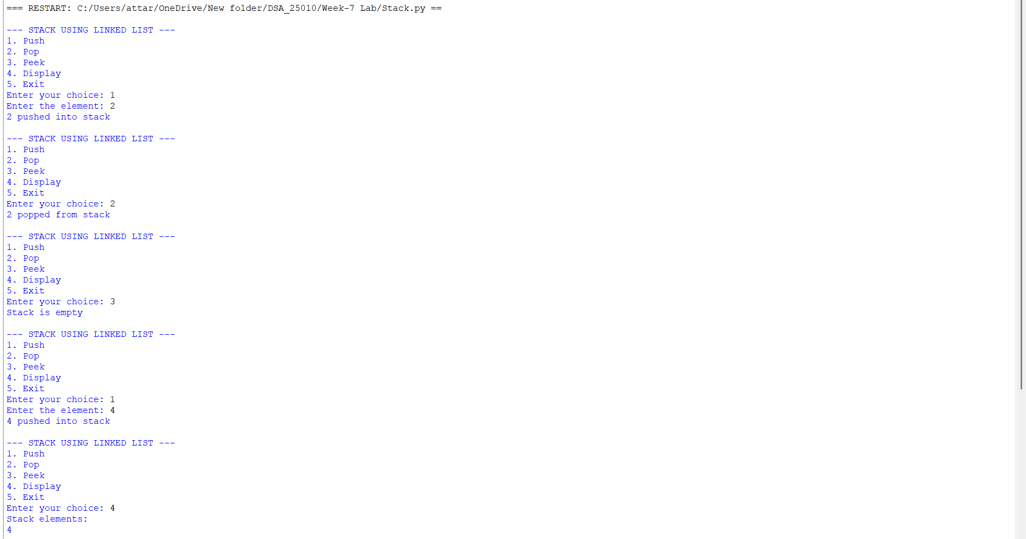
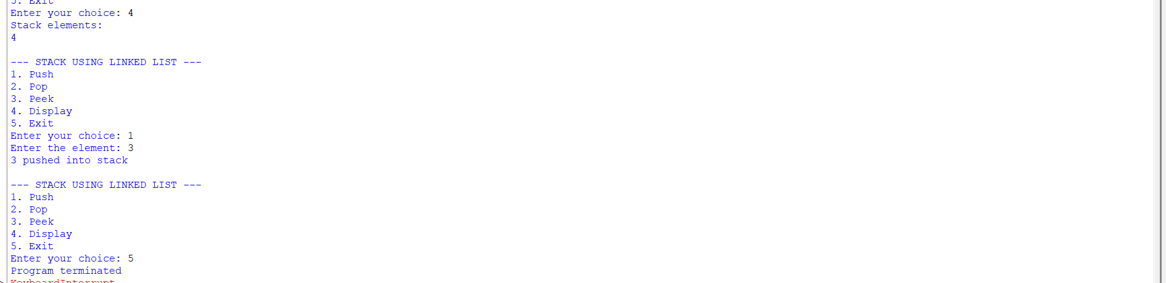

Explanation:
Stack Using Array
Structure:
- Uses a Python list (self.stack) to store elements.
- self.top keeps track of the index of the last pushed element.
- self.size defines the maximum capacity.
Operations:
- Push
  - Check if top == size - 1 → Overflow.
  - Otherwise, increment top and insert the element at that position.
- Pop
  - Check if top == -1 → Underflow (empty stack).
  - Otherwise, remove the element at top, decrement top.
- Peek
  - Shows the element at top without removing it.
- Display
  - Prints elements from top down to 0 (top to bottom order).
Stack Using Linked List
Structure:
- Each element is a Node with:
  - data (value)
  - next (pointer to the next node).
- self.top points to the most recently pushed node.
Operations:
- Push
  - Create a new node.
  - Link its next to the current top.
  - Update top to this new node.
- Pop
  - If top is None → Underflow.
  - Otherwise, remove the node at top and update top to top.next.
- Peek
  - Shows the data at top.
- Display
  - Traverse from top downwards, printing each node’s data.

Error Table:

S.NO. | Error Occured | Rectification
1 | _init_ is used instead of the Python | Replace _init_ with __init__ in both Node and Stack classes.
2 | Stack() may not initialize top correctly because of the incorrect constructor name | Define the constructor as def __init__(self):.
3 | Node(data) may not initialize data and next because of the incorrect constructor name | Define Node constructor as def __init__(self, data):.
4 | ValueError may occur when a non-integer is entered | Enter an integer or use try-except for input validation.
5 | Stack Underflow occurs when Pop is performed on an empty stack | Check self.top is None before performing Pop.
6 | AttributeError can occur if top, data, or next is misspelled | Use the correct attribute names consistently.
7 | NameError can occur if Stack or Node is incorrectly referenced | Use the exact class names Stack and Node.
8 | Stack traversal may be incorrect if top is modified during Display | Use a temporary variable temp for traversal.
9 | IndentationError can occur if Python blocks are not properly indented | Maintain consistent indentation inside classes, methods, loops, and conditions.
10 | Program may not terminate if break is omitted from Exit | Use break when choice == 5.
11 | Invalid menu selection may produce unexpected behavior | Use the final else block to display Invalid choice.
12 | A non-numeric menu input can cause ValueError | Validate the menu input before converting it to an integer.

WEEK-6

WAP python to implement a Queue using an array, linked list ,also implement the stack
operations such as:
a)ENQUEUE
b)DEQUEUE
c)peek also display the stack elements
Code:
class QueueEx:
def __init__(self, size):
self.size = size
self.queue = [None] * size
self.front = -1
self.rear = -1

# Enqueue operation
def enqueue(self, x):
if self.rear == self.size - 1:
print("Queue Overflow")
else:
if self.front == -1:
self.front = 0
self.rear += 1
self.queue[self.rear] = x
print(f"{x} inserted into the queue")

# Dequeue operation
def dequeue(self):
if self.front == -1 or self.front > self.rear:
print("Queue Underflow")
else:
x = self.queue[self.front]
self.queue[self.front] = None
self.front += 1
print(f"{x} deleted from the queue")

# Reset queue when it becomes empty
if self.front > self.rear:
self.front = -1
self.rear = -1

# Peek operation
def peek(self):
if self.front == -1:
print("Queue is empty")
else:
print("Front element:", self.queue[self.front])

# Display operation
def display(self):
if self.front == -1:
print("Queue is empty")
else:
print("The elements of the queue are:")
for i in range(self.front, self.rear + 1):
print(self.queue[i])

# Menu-driven program
size = int(input("Enter the size of the queue: "))
q = QueueEx(size)

while True:
print("\n----- QUEUE MENU -----")
print("1. Enqueue")
print("2. Dequeue")
print("3. Peek")
print("4. Display")
print("5. Exit")
choice = int(input("Enter your choice: "))

if choice == 1:
item = int(input("Enter the element to enqueue: "))
q.enqueue(item)
elif choice == 2:
q.dequeue()
elif choice == 3:
q.peek()
elif choice == 4:
q.display()
elif choice == 5:
print("Program terminated.")
break
else:
print("Invalid choice")
Output:
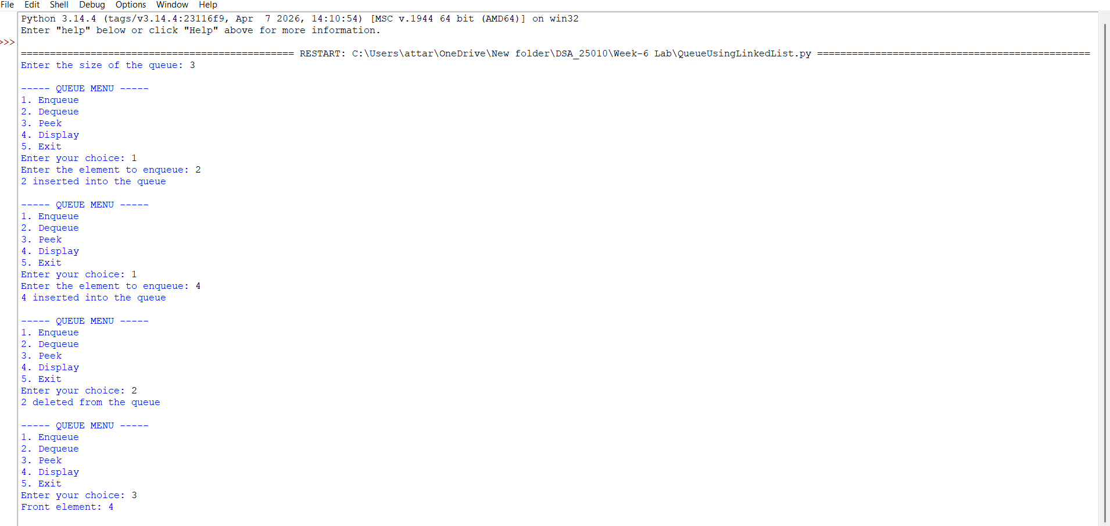
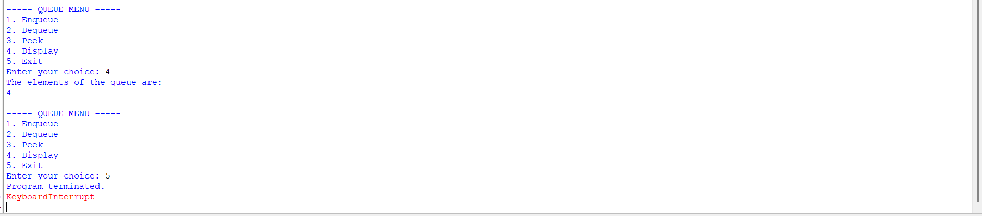
Explanation:
This program implements a Queue using a linked list, allowing First-In-First-Out (FIFO) behaviour with dynamic size. The QueueEx class keeps two pointers: front, which refers to the node that will be removed next, and rear, which refers to the most recently added node — this lets both insertion and removal be performed in O(1) time without traversing the list.The enqueue() method creates a new node and, if the queue is currently empty (rear is None), sets both front and rear to this new node; otherwise, it links the new node after the current rear and then updates rear to point to it, so new elements always join at the back of the queue. The dequeue() method first checks whether front is None (an empty queue, called Queue Underflow); if not, it reads the data at front, advances front to the next node, and — if the queue has now become empty — also resets rear to None so both pointers stay consistent.The peek() method reports the data at front without removing it, and display() walks the list from front to rear, printing every element in the order they would be dequeued. As with the stack program, a menu-driven while loop repeatedly reads the user's choice and calls the matching method, continuing until choice 5 (Exit) is selected, which breaks the loop and ends the program.
Error Table:
S.NO. | Error Occured | Rectification
1 | Queue Underflow | Check if the queue is empty before dequeuing/peeking; enqueue an element first
2 | ValueError: invalid literal for int() | Enter only numeric values, or wrap input() in a try–except block
3 | Invalid choice printed repeatedly | Enter a valid option between 1 and 5
4 | rear left pointing to a stale node | Ensure dequeue() sets rear = None whenever the last element is removed (already handled in this code)

Code(Implementation Using Linked List):
# Node structure
class Node:
def __init__(self, data):
self.data = data
self.next = None

class QueueEx:
def __init__(self):
self.front = None
self.rear = None

# Enqueue operation
def enqueue(self, x):
new = Node(x)
if self.rear is None:
self.front = self.rear = new
else:
self.rear.next = new
self.rear = new
print(x, "inserted into the queue")
# Dequeue operation
def dequeue(self):
if self.front is None:
print("Queue Underflow")
else:
x = self.front.data
self.front = self.front.next
if self.front is None:
self.rear = None
print(f"{x} deleted from the queue")
# Peek operation
def peek(self):
if self.front is None:
print("Queue is empty")
else:
print("Front element:", self.front.data)

# Display operation
def display(self):
if self.front is None:
print("Queue is empty")
else:
print("The elements of the queue are:")
temp = self.front
while temp is not None:
print(temp.data)
temp = temp.next
q = QueueEx()

while True:
print("\n------ QUEUE MENU ------")
print("1. Enqueue")
print("2. Dequeue")
print("3. Peek")
print("4. Display")
print("5. Exit")
choice = int(input("Enter your choice: "))
if choice == 1:
item = int(input("Enter the element to enqueue: "))
q.enqueue(item)
elif choice == 2:
q.dequeue()
elif choice == 3:
q.peek()
elif choice == 4:
q.display()
elif choice == 5:
print("Program terminated.")
break
else:
print("Invalid choice")
Output:
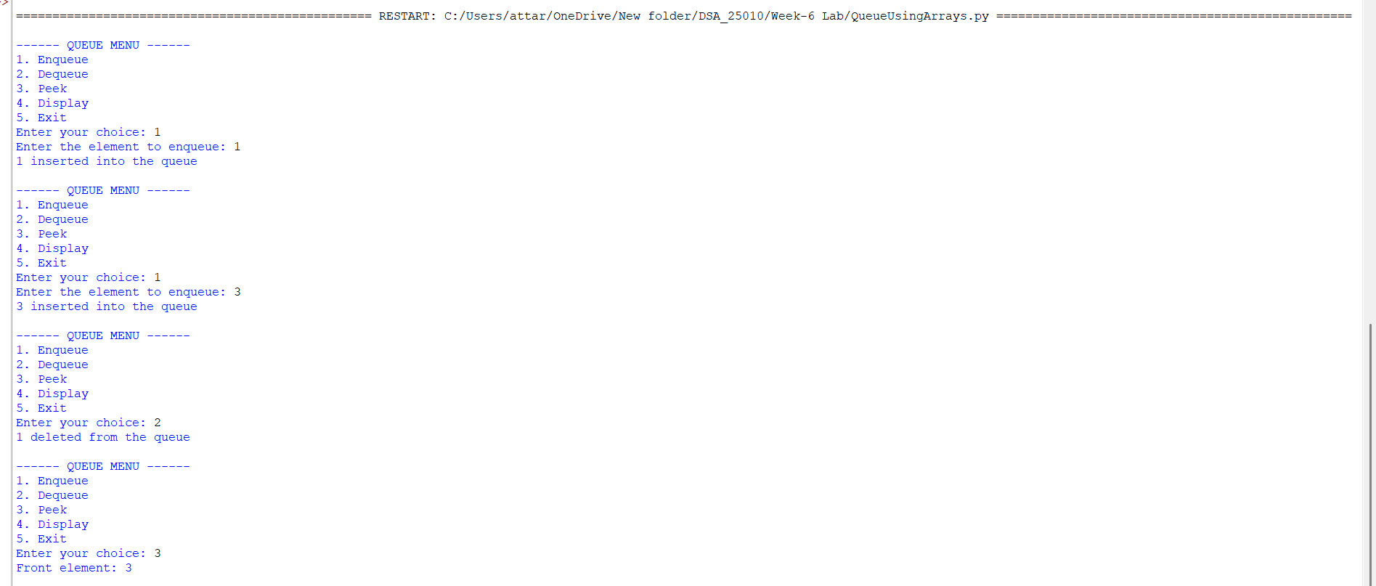
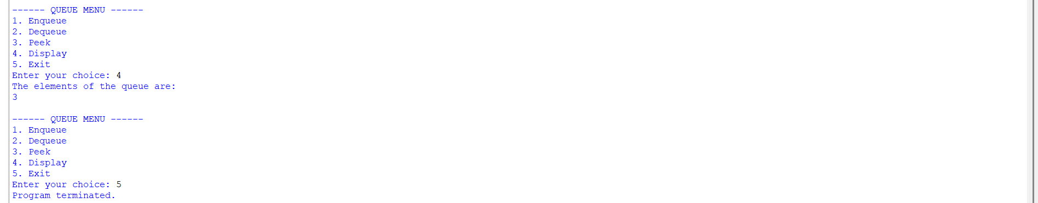
Explanation:
The queue using an array is implemented using a Python list along with two variables called front and rear. The front variable indicates the position from where elements are removed, while rear indicates the position where new elements are inserted. Initially, front is set to 0 and rear is set to -1, indicating that the queue is empty. During the enqueue operation, an element is added to the array and rear is increased. During the dequeue operation, the element at the front position is removed logically by moving front to the next position. The queue follows FIFO so the element inserted first is removed first.
ERROR TABLE:
S.NO. | Error | solution
1 | Queue Overflow | rear == MAX - 1
2 | Queue Underflow | front > rear
3 | Invalid Dequeue | front > rear

